|  |
| --- |
| Robert van der Spoel |
| IT Graad 10 PAT – Fase 1 |
| Circuit Central |
| You may add an image / your own logo (not required) |

Table of Contents

**Define the task** 2

Topic: 2

Purpose of program: 2

Possible solution: 2

Scope: 2

**User Stories** 2

**Acceptance Test – List FOUR Functions** 2

**Data Dictionary** 2

User defined function 2

**Navigation** 3

**GUI Design** 3

Tab Sheet 1 (User 1): 3

INPUT: 3

OUTPUT: 3

Tab Sheet 2 (User 2): 3

INPUT: 3

OUTPUT: 3

**IPO – Software Design Tool** 4

INPUT VALIDATION: 4

PROCESSING: 4

# **Define the task**

## Topic: Computer Part Store. The store sell’s PC parts such as GPU’s, CPU’s and peripherals.

## Purpose of program: The company is new and doesn't have a wide range of customers. It is limited to in store purchases and doesn’t have a website. This problem limits the buyers to only the local residents. The owner doesn’t have a way to manage his customers.

## Possible solution: My program will enables the customer to order products online that will allow them to ask for delivery or in store pickup. This will allow for a wider range of customers as people from other areas can also access the store .On the admin tab

## sheet the admin will be able to control the program. 3 Tab sheets have been dedicated to selling a product to the customer. A tab sheet has been made to allow the customer to checkout.

## Scope: My program will not be able to add new products, remove old products or change the prices of products. It is also limited on the FPS calculator as it only supports a small range of options. The product range is also limited to 12 items.

# 

# **User Stories**

User 1:

| **WHO** | **WHAT** | **WHY** |
| --- | --- | --- |
|  |  |  |
|  |  |  |
|  |  |  |
|  |  |  |

User 2:

| **WHO** | **WHAT** | **WHY** |
| --- | --- | --- |
|  |  |  |
|  |  |  |
|  |  |  |
|  |  |  |

# **Acceptance Test – List FOUR Functions**

* The system
* The system
* The system
* The system

# **Navigation**

# **GUI Design**

## Tab Sheet 1 (Register for a new User):

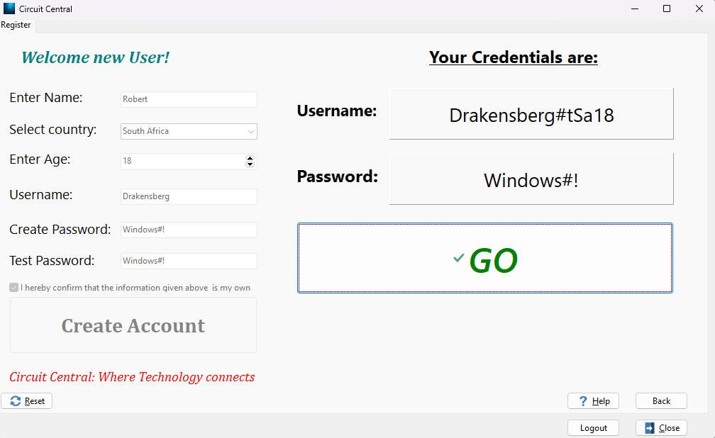

## INPUT:

| **Tabsheet 1 (tsRegister , Caption:’Register’)** | | | | |
| --- | --- | --- | --- | --- |
| **Variable name** | **Data type** | **Format (size, M/F for gender, yyyy/mm/dd)** | **Object Name** | **Local/Global variable** |
| sRegisterName | -String | Just Add your name in the edit using the default format, store the name as a string | edtRegisterName | Local |
| iCountry- | integer | Select Country, store the value as an integer | cmbCountry | Local |
| iAge | Integer | Select or enter age and store the value as an integer | sedAge | Local |
| sUsernameCreate | -string | Create the username and store in a string | edtUsernameCreate | Local |
| sPasswordCreate | string | Enter the password that you want to use and store in a string | edtPasswordCreate | Global |
| sPasswordCheck | string | Re-enter the password that you want to use and store in a string | edtPasswordConfirm | Local |
| bInfoChecked | Boolean | Check or uncheck the checkbox. | chkConfirmDetails | Local |

## OUTPUT:

| **Tabsheet 1 (tsRegister , Caption:’Register’)** | | |
| --- | --- | --- |
| **Output** | **Format (Type, size)** | **Component** |
| Username | Username: <UserName> | Panel |
| Password | Password: <Password> | Panel |

## 

## Tab Sheet 2 (Buy GPU’s):

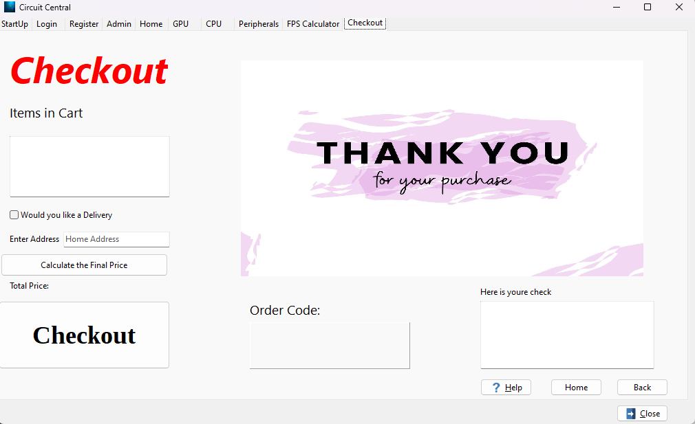

## INPUT:

| **Tabsheet 2 (tsCheckoout caption:’Checkout’)** | | | | |
| --- | --- | --- | --- | --- |
| **Variable name** | **Data type** | **Format (size, M/F for gender, yyyy/mm/dd)** | **Object Name** | **Local/Global variable** |
| bDelevery | Boolean | Select or unselect the checkbox to add funds and delivery to your order or remove it . | chkDelivery | Local |
| sStreetName | String | Enter your Street Name | edtStreetName | Local |
| iHouseNum | Integer | Enter your house Number | edtHouseNumber | Local |
| sOrderCode | String | Generate random numbers and using in and the order Boolean create Order Number for the Customers order | btnCheckout | Local |

## 

## OUTPUT:

| **Tabsheet 2 (tsCheckoout caption:’Checkout’)** | | |
| --- | --- | --- |
| **Output** | **Format (Type, size)** | **Component** |
| Total Price | <Total Price> | label |
| Order Code | <Order Code> | Panel |
| Cheque | <Username>  <Order Details>  <Total Price>  <Order Code> | Rich edit |

# 

# **IPO – Software Design Tool**

## INPUT VALIDATION: For screen One – Register

| **Input** | **Validation technique and description** | **Associated error message** |
| --- | --- | --- |
| Name  -Edit | I will test that there is a name inserted in the Edit | ‘Please Enter your name’ |
| Name  -Edit | I will test that the name entered in the edit is 2 characters or longer | ‘Please enter a name with two or more letters’ |
| Country  -Combo box | I will test that a country has been selected in the combo box | ‘Please select a country from the list provided’ |
| Age  -Spin edit | I will test that the user is older than 18 years old | ‘You must be at least 18 years old to create an account’ |
| Age  -Spin edit | I will test that the user is younger than 100 years old | ‘You must be younger than 100 years to create an account , please ask a family member for assistance’ |
| Username  -Edit | I will test that there is an username entered in the edit | ‘Please create an username’ |
| Username  -Edit | I will test that the username entered is equal or longer that 5 characters | ‘Username to short , must be at least 5 characters’ |
| Username  -Edit | I will test that the Username entered is equal or shorter than 10 characters | ‘Username to long , must me shorter than 10 characters’ |
| Username  -Edit | I will test that the username entered is only on word | ‘Username can only me one word’ |
| Password  edit | I will test that a password has been entered in the edit | ‘Please enter a Password’ |
| Password  Edit | I will test that the password contains at least 5 characters | ‘Password must contain at least 5 characters’ |
| //Below  Password  Edit | I will test that the password is not longer that 10 characters | ‘Password should be shorter than 10 characters’ |
| Password Test  Edit | I will test that a password has been entered in the edit | ‘Please enter the password again to make sure you know it’ |
| Password Test  Edit | Check that the password entered in the test password edit is the same as the password entered in the create password edit | ‘Passwords do not match’ |

## 

## PROCESSING:

|  |  |
| --- | --- |
| **What processing will be done** | **Algorithms, formulas, etc.** |
| **List:** | **Algorithms:** |
| 1Login :  Determine if the user is an admin or a customer or if the user does not exist when the login button is clicked | sUsername = input from user (edit)  sPassword = input from user(Edit)  iTries = 0  sCredentials = sUsername + sPassword  if sCredentials = sCredentialsAdmin  Show admin page  Set to admin page  Show all user Pages  Else  If sCredentials = sCredentialsPresetUserOne  Set to home Page  Make all other user pages available  Else  If If sCredentials = sCredentialsPresetUserCreate  Set to home Page  Make all other user pages available  {Else  iTries + 1  if iTries > 1  button to Register = visible  Show a message: ‘No account? Register Today’  Else  Show error message: ‘Please Check Credentials’} |
| 2Register:  Create a new account for the user and display there login details | sNameRegister = input from user(edit) – Name of User  sCountry = input from user (Country of user)  iAge = input from user(Spin edit)  sUsernameCreate = input from user (edit)–User Choose UserName  sPasswordCreate = input from user(edit)- User Choose Password  sPasswordTest = input from user(edit)- User re-enters password  cNamelastLetter = last letter of sNameRegister  cCountryFirstLetter = first letter of sCountry  cCountryLastLetter = last letter of sCountry  sUsernameTag = cNamelastLetter + cCountryFirstLetter + cCountryLastLetter + iAge  sRegisterUsername = sRegisterOwnUser + # + sUsernameTag  Show Username  Show Password  Show GO button |
|  |  |